Summary

From the results, the Chi-square goodness of Fit showed that there was a statistical difference of class grade over the semesters. It also showed that there was a statistical difference in grades and semesters with prequizzes and those without prequizzes. The chi-square also showed that the percentage of passing grades differed from semester to semester. The linear model showed that there was a trend of grades and percentage passing score determined by time. The multiple linear regression model showed that class grade could be determined using %passing score and prequizzes taken since they were statistically significant with sig. values 0.005 and 0.003 respectively at 95% confidence interval. Prequizzes was the most significant factor that determined class grade.

- Yes. There was a significant statistical difference of grades from semester to semester. The chi-square goodness of fit test was used to determine the difference at 95% level of greater than 10. This proved that students varied their grades from semester to semester. The values of the semester variable were fist recoded before running the chi-square . F2013 was recoded to 1, F2014 to 2, W2015 to 3, F2015 to 4, W2016 to 5, and F2016 to 6 Semester value was changed to Sem1. The results were as follows
Table 1: Chi-square results

Test Statistics
 | Class | Sem1
Chi-Square | 128.782ª | 34.966^{b}
df | 271 | 5
Asymp. Sig. | 1.000 | .000
a. 272 cells (100.0%) have expected frequencies less than 5. The minimum expected cell frequency is 1.3.
b. 0 cells (0.0%) have expected frequencies less than 5. The minimum expected cell frequency is 58.0.

X² = 128.72, Value = 1.00 for class and X² = 34.966, Value = 0.00. The Chi-square had a strong effect hence proved that grades differed from semester to semester.

Table 2: Expected and observed values for grades per semester
Sem1
 | Observed N | Expected N | Residual
1.00 | 69 | 58.0 | 11.0
2.00 | 93 | 58.0 | 35.0
3.00 | 49 | 58.0 | -9.0
4.00 | 36 | 58.0 | -22.0
5.00 | 49 | 58.0 | -9.0
6.00 | 52 | 58.0 | -6.0
Total | 348

The expected grade for all the semesters was 58.0 which strongly differed with the
observed mean grade for each semester. The observed means for the four semesters were;

69, 93, 49, 36, 49, and 52 f respectively.

- Yes. A chi-square goodness of fit was tested on the grades and semesters with prequizzes and those without prequizzes. The results showed that there was a statistical difference between grades and semesters. The results were as follows
Table 3: Observed and expected means

prequizzes
 | Observed N | Expected N | Residual
.0 | 13 | 6.5 | 6.5
1.0 | 18 | 6.5 | 11.5
2.0 | 12 | 6.5 | 5.5
3.0 | 2 | 6.5 | -4.5
4.0 | 7 | 6.5 | .5
5.0 | 7 | 6.5 | .5
6.0 | 8 | 6.5 | 1.5
7.0 | 4 | 6.5 | -2.5
8.0 | 8 | 6.5 | 1.5
9.0 | 7 | 6.5 | .5
10.0 | 8 | 6.5 | 1.5
11.0 | 1 | 6.5 | -5.5
12.0 | 4 | 6.5 | -2.5
13.0 | 3 | 6.5 | -3.5
15.0 | 3 | 6.5 | -3.5
16.0 | 7 | 6.5 | .5
17.0 | 9 | 6.5 | 2.5
18.0 | 5 | 6.5 | -1.5
19.0 | 5 | 6.5 | -1.5
20.0 | 5 | 6.5 | -1.5
21.0 | 1 | 6.5 | -5.5
Total | 137

From the results the expected means was 6.5 whereas the observed means varied hence proving that student grades were affected by semesters with prequizzes and those without.

Table 4: Chi-square results

Test Statistics
 | Class | prequizzes
Chi-Square | 128.782ª | 52.613^{b}
df | 271 | 20
Asymp. Sig. | 1.000 | .000
a. 272 cells (100.0%) have expected frequencies less than 5. The minimum expected cell frequency is 1.3.
b. 0 cells (0.0%) have expected frequencies less than 5. The minimum expected cell frequency is 6.5.

The Chi-square test had a strong effect where the prequizzes were X² = 52.613, df = 20. Class grade X² = 128.782, df = 271. These proved that there was a statistical difference of class grades between semesters with prequizzes and semesters without.

- Yes. There was a significant statistical difference. The observed mean grades above 2 varied. They were 93, 49, 36, 49, 52 respectively and their expected values were 58.0.
Table 5: Observed and expected means of grades
Sem1
 | Observed N | Expected N | Residual
1.00 | 69 | 58.0 | 11.0
2.00 | 93 | 58.0 | 35.0
3.00 | 49 | 58.0 | -9.0
4.00 | 36 | 58.0 | -22.0
5.00 | 49 | 58.0 | -9.0
6.00 | 52 | 58.0 | -6.0
Total | 348

Table 6: Chi-square results

Test Statistics
 | PQ avg | Sem1
Chi-Square | 140.007ª | 34.966^{b}
df | 109 | 5
Asymp. Sig. | .024 | .000
a. 110 cells (100.0%) have expected frequencies less than 5. The minimum expected cell frequency is 1.2.
b. 0 cells (0.0%) have expected frequencies less than 5. The minimum expected cell frequency is 58.0.

X² ⁼ 140.007, Value = 0.24. The Chi-square result for semesters was X² = 34.966, Value = 0.000 which was greater than 10 and had a strong effect to the percentage pass grade.

- a.) Yes. Student grades were regressed against semesters and assumed a linear model and this showed a trend of grades over time.
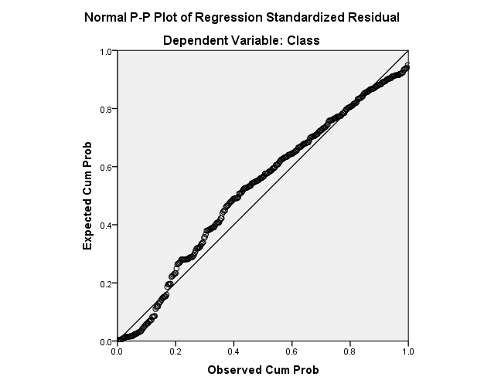
Figure 1: Regression line
The data also assumed a normal distribution.

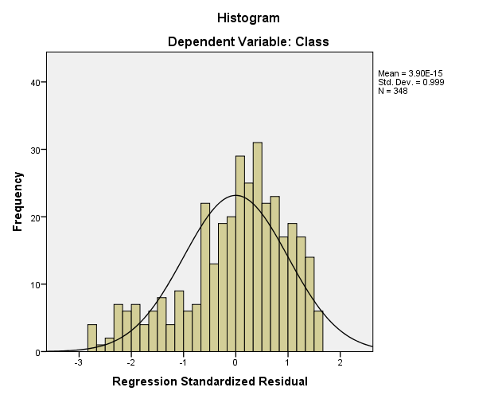
Figure 2: Normal plot

Table 7: Mode summary

Model Summary^{b}
Model | R | R Square | Adjusted R Square | Std. Error of the Estimate
1 | .042ª | .002 | -.001 | .9354382
a. Predictors: (Constant), Sem1
b. Dependent Variable: Class

From the results R = 0.042. The model was able to predict 42% of student grades over the semesters.
Table 8: Anova results

ANOVAª
Model |  | Sum of Squares | df | Mean Square | F | Sig.
1 | Regression | .538 | 1 | .538 | .615 | .434^{b}
1 | Residual | 302.765 | 346 | .875
1 | Total | 303.303 | 347
a. Dependent Variable: Class
b. Predictors: (Constant), Sem1
The F value = 0.615, value = 0.434 was greater than Alpha = 0.05 hence the null hypothesis that student grades were not affected by semesters was rejected.

Table 9: Co-efficients results

Coefficientsª
Model |  | Unstandardized Coefficients |  | Standardized Coefficients | t | Sig.
 |  | B | Std. Error | Beta | t | Sig.
1 | (Constant) | 2.566 | .104 |  | 24.671 | .000
1 | Sem1 | -.023 | .029 | -.042 | -.784 | .434
a. Dependent Variable: Class

The model equation was Y = -0.023*X1 + 2.566 which was not sufficient to predict student grades over time. This was because semesters had a level of significance of 0.434 which was greater than alpha = 0.05.

b.) Percentage passing was also regressed against semesters with semesters being the independent variable and percentage passing being the dependent variable. The linear model showed trend of percentage passing over time.
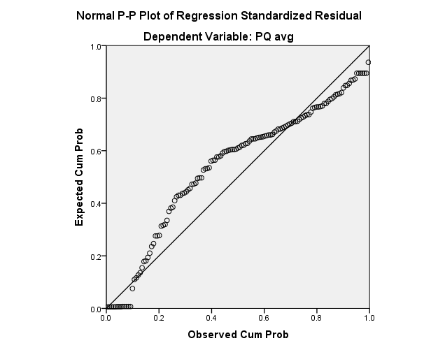

Figure 3: Regression line

The data assumed a normal distribution
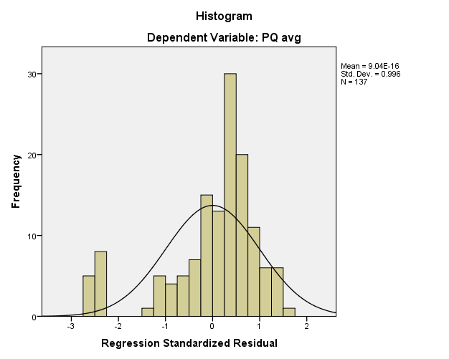

Figure 4: Normal plot

Table 10: Model summary

Model Summary^{b}
Model | R | R Square | Adjusted R Square | Std. Error of the Estimate
1 | .034ª | .001 | -.006 | 23.78626%
a. Predictors: (Constant), Sem1
b. Dependent Variable: PQ avg

The R was 0.34 and this showed that the model was only able to predict 34% of percentage passing over the semesters.

Table 11: Anova results

ANOVAª
Model |  | Sum of Squares | df | Mean Square | F | Sig.
1 | Regression | 90.833 | 1 | 90.833 | .161 | .689^{b}
1 | Residual | 76381.125 | 135 | 565.786
1 | Total | 76471.958 | 136
a. Dependent Variable: PQ avg
b. Predictors: (Constant), Sem1

From the results, the F Value = 0.161, value 0.689 was greater than α = 0.05, hence we rejected the null hypothesis that percentage passing was not affected by the semesters.

Table 12: Co-efficients results

Coefficientsª
Model |  | Unstandardized Coefficients |  | Standardized Coefficients | t | Sig.
 |  | B | Std. Error | Beta | t | Sig.
1 | (Constant) | 64.299 | 13.271 |  | 4.845 | .000
1 | Sem1 | -1.027 | 2.563 | -.034 | -.401 | .689
a. Dependent Variable: PQ avg

From the results the linear equation was Y = -1.027*X1 + 64.299 which was not sufficient to predict percentage passing over time since semesters had a Sig. = 0.689 which was greater than α = 0.05.

- a.) Does the student’s last academic class year standing () contribute to their final grades.
b.) Are grades different in fall and winter system.
c.) Number of prequizzes taken.
d.) percentage on average received on prequizzes.

Multiple linear regression was used to predict which factors determined student grades. The data assumed a linear model that showed that there was a linear relationship between grades and the independent variables. Academic class last year standing values were recoded such that
1 represented freshman, 2- junior, 3 – Sophomore, 4 – post – Bachelor, and 5 – Non – matriculated.
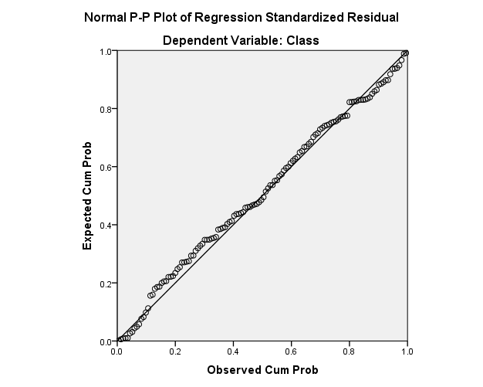

Figure 5: Regression line

The data assumed a normal distribution
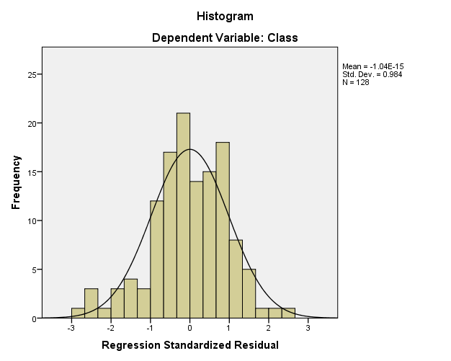

Figure 6: Normal distribution plot
Table 13: Model summary

Model Summary^{b}
Model | R | R Square | Adjusted R Square | Std. Error of the Estimate
1 | .515ª | .266 | .242 | .7794495
a. Predictors: (Constant), PQ avg, Sem1, 2, prequizzes
b. Dependent Variable: Class

From the results, R = 0.515 which showed that the model predicted 51.5% of the grades were determined by the independent variables.

Table 14: Anova results
ANOVAª
Model |  | Sum of Squares | df | Mean Square | F | Sig.
1 | Regression | 27.013 | 4 | 6.753 | 11.116 | .000^{b}
1 | Residual | 74.728 | 123 | .608
1 | Total | 101.740 | 127
a. Dependent Variable: Class
b. Predictors: (Constant), PQ avg, Sem1, 2, prequizzes

From the results, F = 11.116, Value = 0.000 which was less than α = 0.05 hence we accepted the null hypothesis that not all factors determined the class grade.
Table 15: Coefficients results

Coefficientsª
Model |  | Unstandardized Coefficients |  | Standardized Coefficients | t | Sig. | 95.0% Confidence Interval for B
 |  | B | Std. Error | Beta | t | Sig. | Lower Bound | Upper Bound
1 | (Constant) | 2.222 | .532 |  | 4.180 | .000 | 1.170 | 3.274
1 | Sem1 | -.179 | .095 | -.160 | -1.876 | .063 | -.367 | .010
1 | 2 | .122 | .088 | .111 | 1.385 | .169 | -.052 | .296
1 | prequizzes | .040 | .013 | .295 | 3.032 | .003 | .014 | .067
1 | PQ avg | .010 | .004 | .269 | 2.880 | .005 | .003 | .018
a. Dependent Variable: Class

From the results, prequizzes and percentage passing were significant with 0.003 and 0.005 levels of significance respectively, at 95% confidence level. The linear equation was therefore concluded to be: Y = 0.04*X1 +0.10*X2 + 2.222.

